**Running Head**

*Functional traits and forest fire regimes*

**Title**

The biogeography of forest fire regimes: a trait-based approach

**Authors**

Jens T. Stevens 1*, Matthew Kling, Dylan W. Schwilk, J. Morgan Varner#, Jeffrey Kane##

**Author Affiliations and Addresses**

1U.S. Geological Survey, New Mexico Landscapes Field Station, Santa Fe NM

2University of California Berkeley, Department of Integrative Biology, Berkeley CA

3Texas Tech University, Department of Biological Sciences, Lubbock, TX

4U.S.D.A. Forest Service, Pacific Wildland Fire Sciences Laboratory, Seattle, WA

5Humboldt State University, Department of Forestry and Wildland Science, Arcata, CA

*Corresponding Author

**Journal requirements for “Research Communications”:**

Abstract: 150 words; Article: 2500 words; References: 20; figures/tables: 3 (+SI)

**Current stats:**

Abstract: 125 words; Article: ~2700 words; References: 27; figures/tables: 4 (+SI)

(Could merge Figures 2 and 3 into a “2a and 2b”)

**Abstract**

Functional traits are a critical link between species distributions and the ecosystem processes that structure those species’ niches. Concurrent increases in the availability of functional trait data and our ability to map and model species distributions presents an opportunity to develop functional trait biogeography to improve process-based predictions about the adaptability of certain species assemblages to changing environmental conditions across landscape scales. We illustrate this concept by developing the first multivariate, trait-based quantitative ranking of fire resistance in North American conifer species. A map of fire resistance of different conifer species assemblages across the western US reveals general agreement with independent assessments of historical fire regimes, while also identifying areas where the adaptive capacity of current species assemblages may be mismatched with historical fire regimes.

**Introduction**

Functional traits have become a critical component of community ecology in the past decade, improving our understanding of how environmental niches are expressed by shared traits (McGill et al. 2006). Despite rapidly expanding databases of functional trait information, particularly for plants (Kattge et al. 2011), studies of niche dynamics using functional traits often focus at relatively small spatial scales (Messier et al. 2010), and scaling up functional trait studies to describe ecosystem processes at the landscape scale has been challenging (Funk et al. 2017)[. Advances in remote sensing technology and species distribution modeling have created an opportunity to integrate landscape models of species abundances with functional trait information via the concept of functional trait biogeography, to better understand how ecosystem processes structure species niches at increasingly large spatial scales. To illustrate this concept, we apply functional trait biogeography to describe regional variation in adaptive fire regimes within conifer-dominated forests](#_ENREF_5" \t "Funk, 2017 #3664) and woodlands of the western U.S.

Mapping of historical and contemporary fire regimes is useful to model spatial variation in characteristic ecosystem response to wildland fire across a landscape (Schoennagel and Nelson 2011). Such models are generally based on historical fire return intervals, climate, predominant vegetation, and biophysical models that link these parameters together (Rollins 2009). Implicit in these models, particularly in forested ecosystems, is the recognition that there is functional trait variation among species of the predominant vegetation (e.g., trees) that influences the likelihood of the tree surviving a fire (Figure 1). Functional traits can influence tree survival during fire by mediating the direct physiological response of the tree to fire, or the way that fuel characteristics of the tree influence fire spread (Keeley et al. 2011). It is common practice to rank species along a continuum from “fire-tolerant” to “fire-intolerant” (e.g., Brown and Smith 2000, Safford and Stevens 2017), but these species rankings are often based on a qualitative understanding of species’ natural history rather than a quantitative assessment of traits that are associated with surviving fire, and quantitative variation in these traits has not been explicitly linked to variation in fire regimes at a landscape scale.

Given the inverse relationship between fire frequency and intensity (Steel et al. 2015), tree species that experience more frequent fire over their evolutionary history have an opportunity to evolve fire resistance traits, i.e. morphological characteristics that improve a tree’s likelihood of surviving a surface fire under low to moderate fire weather conditions (Keeley et al. 2011, Pausas 2015). We conceptualize fire resistance (or fire tolerance) as the ability of adult trees to withstand surface fire. We distinguish this fire adaptation strategy from other fire-adapted life history strategies such as “fire embracing” or “fire resilient” strategies that involve loss of adult aboveground biomass and fire-adapted regeneration via resprouting or serotiny, which may be adaptive under less frequent, higher intensity fire regimes (Schwilk and Ackerly 2001, Pausas et al. 2017)

A set of traits associated with fire resistance – thick bark, a high degree of self-pruning lower branches, and tall maximum heights – are often strongly correlated with each other (Schwilk and Ackerly 2001). Bark thickness is strongly associated with tree survival of moderate-intensity surface fires (Pausas 2015, Lutes and Keane 2017), while greater tree heights and self-pruning of lower branches reduce the likelihood that fire will enter the crown and kill the tree via crown scorching or torching (Schwilk and Ackerly 2001).

Litter flammability traits may also be associated with tree sensitivity to fire. Under a two-dimensional flammability trait space (Pausas et al. 2017), “fast-flammable” evolutionary strategies are generally associated with greater flame lengths, percent consumption, and spread rates (axis 1, Pausas et al. 2017), but lesser flame and smoldering duration and total heat release (axis 2). Conversely, “hot-flammable” strategies are generally associated with moderate flame heights, percent consumption and spread rates (axis 1), but greater flame and smoldering duration and more total heat release (axis 2), and “non-flammable” species generally have lesser values for all flammability traits. Species with thick bark and high self-pruning also tend to have leaf litter conducive to “fast-flammable” fire behavior, which may promote tree survival by promoting rapid fire spread and minimizing cambial exposure to lethal temperatures (Pausas 2015, Varner et al. 2015)[.](#_ENREF_15" \t "Pausas, 2017 #3389)  Such leaf litter traits are often associated with shade-intolerant and fire-dependent species that experience frequent fire (Schwilk and Caprio 2011, de Magalhaes and Schwilk 2012), whereas species that are less likely to experience fire during their lifetimes, due to a combination of climate and fuel limitation, may have less selective pressure to develop these “fast-flammable” traits (Keeley et al. 2011, Pausas et al. 2017).

The collective ability of trees to resist fire is one indicator of forest resilience to the increase in fire activity expected across western North America in the future under increased human development and climate change (Johnstone et al. 2016). Historical fire suppression has shifted species composition in some regions away from more fire-resistant species toward fire-sensitive species (Safford and Stevens 2017). It is therefore critical to describe the current condition of forest communities as a function of constituent species’ ability to survive fire as adults. We quantified the biogeography of fire resistance (adult tree survival) in forests of the western United States by integrating functional traits with spatially-explicit data on species distributions and abundance. We use this approach to highlight important biogeographic variation in likely fire effects across a landscape, to provide an independent assessment of other spatial models of fire regimes, and to identify areas where the current species composition is mismatched with historical and future expected fire frequency.

**Methods**

We assembled a quantitative trait database on six fire-adaptive traits that contribute to fire resistance of 29 widespread western conifer species. Our trait database included three traits relating to tree morphology – bark thickness, maximum tree height, and degree of self-pruning – and three traits relating to litter flammability – flame length, percent consumption, and flame duration. We estimated the bark thickness of a 25.4 cm (10 in) diameter at breast height (dbh) tree using the species-specific bark thickness multipliers from the First Order Fire Effects Model (Lutes and Keane 2017). These multipliers assume a linear rate of bark accumulation with dbh, which is not realistic for many species, but they are currently the most widely-used trait in models of fire-caused mortality, and they capture general differences among species (Lutes and Keane 2017). Maximum tree height was derived from the TRY plant trait database (Kattge et al. 2011). Degree of self-pruning was assigned on an ordinal 1-10 scale following the methods and data for the genus *Pinus* from Keeley and Zedler (1998) and Schwilk and Ackerly (2001), supplementing with data for other genera from the Fire Effects and Information System (FEIS 2013).

Flammability data on mean flame length, percent litter consumption, and flame duration were obtained from (Fonda 2001), (Fonda et al. 1998), Banwell and Varner (unpublished data) and Kane (unpublished data). Flame height and percent consumption were very tightly correlated (Pearson’s r = 0.93; Fig. S1), so to avoid double-counting we performed a principal component analysis of those two traits and used the first axis (PC1), which explained 96.7% of the variance, to account for these two traits simultaneously (Table 1). Flame height and percent consumption were non-linearly correlated with flame duration, with the shortest flame durations associated with both the lowest flame heights and the highest flame heights (Fig. S1). Together, PC1 and flame duration represent the two-dimensional trait space for litter flammability, with PC1 Species scoring in the most fire-resistant percentiles of PC1 (high flame height and high percent consumption) and flame duration (short durations) occupy the “fast-flammable” evolutionary niche associated with fire-surviving species (Pausas et al. 2017).

We selected conifer tree species for analysis based on the species database of the US Forest Service Forest Inventory and Analysis (FIA) National Core Field Guide (USDA Forest Service FIA Program 2014)[. We identified species classified by FIA as “Western”, with distributions overlapping our eleven-state study area, and that had spatially](#_ENREF_24" \t "USDA Forest Service FIA Program, 2014 #2618) explicit basal area data available (see below). Our resulting trait database consisted of 29 widespread conifer species in western North America (Table 1), and each quantitative trait had a distribution of values across all species in the dataset (Fig. S1). To standardize and combine the traits into a single quantitative estimate of a “fire resistance score” (FRS), for each trait we calculated the percentile of each species relative to all species in the study, with the species possessing the most fire-resistant form of the trait assigned a percentile value of 1. We defined the most fire-resistant form of a trait as the thickest bark, tallest maximum height, greatest degree of self-pruning, shortest flame duration, and the combined tallest flame length and highest percent consumption using PC1 as described above. FRS for each species was then calculated as simply the average of its five percentile scores for the six traits (Table 1).

Each species in our traits database had a distribution map covering the western US, representing estimated basal area (m2 ha-1) at 250 m resolution, developed by Wilson et al. (2013)[. These layers are based on imputed basal area per species from FIA plots, using statistical relationships between basal area and climatic and topographic variables. Validation suggests fairly high accuracy, particularly for widespread species](#_ENREF_26" \t "Wilson, 2013 #3063) (Riemann et al. 2010, Wilson et al. 2013). We first identified our area of inference (conifer forests) by calculating the total basal area per pixel of all 29 species in our traits database relative to the total basal area of all other western species, which primarily included hardwoods. We restricted our analysis to only those areas where >50% of the total tree basal area was comprised of species in our traits database, and where the basal area of our study species exceeded 5 m2 ha-1. We then estimated the relative basal area fraction of each of our 29 species within each pixel, and multiplied the FRS of each species by its relative abundance in a given pixel (which could include 0) to derive a community-weighted mean FRS at the pixel scale.

We compared the FRS map to LANDFIRE-derived indices of historical fire regimes (www.landfire.gov), using the fire regime group (FRG) and mean fire return interval (FRI) layers. FRG and FRI layers were resampled to the same spatial resolution as our FRS data (250 m). The LANDFIRE FRI product classifies pixels as having mean fire return intervals within a range of years (e.g., classes of 0-5 years, 6-10 years); we simplified this classification by merging into fewer classes and assigning the median fire return interval of the merged LANDFIRE classes as the pixel value (5, 15, 25, 35, 50, 100, 200 and 500-year return intervals). On a random 1% subsample of the full landscape (N=94901), we tested whether different fire regime groups had significantly different FRS, and whether FRS decreased as a function of lengthening fire-return intervals.

To quantify potential imbalances between historical fire regimes and current composition, we identified forest areas where the current species composition may be more or less resistant to fire than expected given estimated historical fire frequency. Specifically, we sought to identify 1) fire-vulnerable forests with frequent historical fire (“vulnerable-frequent”, 2) fire-vulnerable forests with intermediate historical fire (“vulnerable-intermediate”), 3) fire-resistant forests with intermediate historical fire (“resistant-intermediate”) and 4) fire-resistant forests with infrequent historical fire (“resistant-infrequent”). We defined frequent fire as 1-20 year FRI’s in LANDFIRE, intermediate fire as 41-150 year FRI’s, and infrequent fire as 151-300 year FRI’s. We calculated the FRS percentile of every pixel of a given fire frequency class and identified the 20 percent of pixels on either the fire-resistant or fire-vulnerable tails of the distribution within that fire frequency class.

**Results and Discussion**

The trait values for our 29 species (Table 1) were significantly correlated among bark thickness, tree height, and self-pruning (Fig. S1), but less so amongst flammability traits of flame height and flame duration. Fire-resistance scores ranged from a high of 0.85 for *Sequoia sempervirens* (coast redwood) to a low of 0.15 for *Pinus edulis* (piñon pine). The fire-resistance scores segregated ordinally into four groups which reflected our a priori knowledge of the species in question (Fig. 2). The five highest-ranking species are known to inhabit historically frequent-fire ecosystems and have well-documented fire scar records, including *Pinus ponderosa* and *Sequoia giganteum* (FEIS 2013). The next three species are commonly found in mixed-conifer stands with historically frequent fire, but are rarely the dominant species in those stands. A large group of 11 species in the middle of the rankings includes many species found in more mesic mixed-conifer stands that often occupy shade-tolerant and late-seral niches, ranging from *Calocedrus decurrens* at the high end, a common secondary component of *Pinus ponderosa* forests in California, to *Pinus contorta* at the low end, a borderline subalpine species that is known to be fire-intolerant (Fig. 1). Finally, the ten lowest-ranking species occupy marginal forests at either higher subalpine elevations (e.g., *Abies lasiocarpa* and *Picea engelmannii*) or lower desert elevations (e.g., *Juniperus scopulorum* and *Pinus edulis*) where fires are rare.

Community-weighted mean FRS varied strongly across the landscape (Fig. 3), and were generally consistent with LANDFIRE estimates of fire regime group (FRG; Fig. S2) and fire return interval (FRI; Fig. S3). FRS was significantly greater in FRG 1 (frequent) than either of the other FRG’s analyzed (Fig. S4). FRS also decreased significantly with increasing FRI (Fig. 2; t=-54.54, df=134451, P<0.0001), however the median FRS increased in the longest FRI class (greater than 300 years, classified as 500 years in our regression analysis; Fig. S4).

These extreme high-end FRI values >300 years (generally associated with FRG 5) are common in the western slopes of the Cascade Range in the Pacific Northwest, where forest biomass is very high but high precipitation and atmospheric moisture limit favorable conditions for fire spread. This area had the most fire-resistant functional traits of all areas classified as intermediate or infrequent FRI’s (Fig. S5), and is dominated by *Pseudotsuga menziesii* and *Tsuga heterophylla*, two moderately fire-resistant species (FEIS 2013). The dominance of these moderately-resistant species in a climatically unsuitable region for fire suggests a degree of fire resistance in these stands, however fuel loads in this region are quite high and would likely overwhelm trait-based fire resistance in these forests in the event of a fire. The redwood forests of coastal California are similarly dominated by a very fire-resistant species (*Sequoia sempervirens*) in a region where fire is often climate-limited, however this region has a record of historically frequent fire (Fig. S3) that is likely due to Native American influence in the region (Steel et al. 2015).

A quantitative assessment of community fire resistance at a landscape scale has practical implications, as the relative abundance of tree species that are less resistant to fire in mixed-species stands can be used to identify areas within a landscape that might have been fire-free since the establishment of those trees, which can allow inferences of past extent of stand-replacing fire effects in these stands (Yocom-Kent et al. 2015). Thus, regions dominated by species that are less fire resistant are presumed to have experienced characteristically infrequent, stand-replacing fire historically. In fire-prone regions where fire suppression has led to encroachment of fire intolerant species, the reduction of these species in mixed stands (via mechanical methods or prescribed fire) is often an objective of restoration (Larson et al. 2013, Safford and Stevens 2017)[. We identified such areas as including mixed-conifer stands of northern California and the eastern slopes of the northern Cascade Range, as well as forests dominated by](#_ENREF_18" \t "Safford, 2017 #2769) *Pinus edulis* on the margin of *Pinus ponderosa* stands in the southwest (Fig. S5).

Another emergent property of the biogeography of fire regimes from our functional trait analysis is that the most fire-resistant stands often occupy mid-elevation montane forests (e.g., the northern Kaibab Plateau in Arizona, Fig. 3). This is consistent with the relationship between climate, fuels, and fire regimes where low fuel loads due to arid conditions limit fire spread in lower montane regions (e.g., pinon-juniper woodlands) and climate (cold and/or wet conditions) limits fire spread in subalpine forests where fuel conditions could otherwise support fire spread (Steel et al. 2015, Safford and Stevens 2017). The least fire-resistant species occupy these elevational extremes (Fig. 2), and thus even surface fires in these regions may lead to extensive tree mortality (Yocom-Kent et al. 2015).

Most conifer species are killed by crown fire, and under extreme weather conditions and high fuel loads, the risk of crown fire increases.

By mapping functional traits across a landscape and validating pattern with independent data on relevant ecosystem processes, we illustrate how functional trait biogeography can be used to construct spatial layers of geographic niche environments (in this case, adaptive niches structured by fire). Such approaches promise to be valuable for “scaling-up” functional traits to better understand ecosystem processes (Funk et al. 2017)[, and predicting how changes to those processes, such as increasing fire frequency with climate change or increases in fuel loads that promote high-severity fire, may result in niche shifts. Functional traits such as those that confer fire resistance are](#_ENREF_5" \t "Funk, 2017 #3664) *adaptive* under certain conditions (Schwilk and Ackerly 2001), but may not be *adapted* to future conditions. Thus incorporating functional traits into biogeographic studies provides a direct link to the adaptive processes relevant to sustain particular species under a rapidly changing environment.

**Acknowledgments**: Feel free to add.

**Table 1**: Trait data and fire resistance scores (FRS) for widespread western US conifers used in the analysis. Table is ordered by decreasing FRS.

|  |  |  |  |  |  |  |  |  |  |  |  |  |  |
| --- | --- | --- | --- | --- | --- | --- | --- | --- | --- | --- | --- | --- | --- |
|  | Values1 | | | | | |  | Percentile of range | | | | |  |
| Scientific name | Bark thickness | Plant height | Self pruning | Flame height | Percent consumed | Flame duration |  | Bark thickness | Plant height | Self pruning | PC12 of fh and pc | Flame duration3 | **FRS** |
| *Sequoia sempervirens* | 2.06 | 95.2 | 5 | 59.4 | 86.1 | 73.4 |  | 1.00 | 1.00 | 0.44 | 0.85 | 0.87 | 0.83 |
| *Pinus jeffreyi* | 1.73 | 51.4 | 10 | 67.3 | 90.0 | 79.2 |  | 0.78 | 0.48 | 1.00 | 0.93 | 0.82 | 0.80 |
| *Pinus ponderosa* | 1.60 | 41.2 | 10 | 77.0 | 92.0 | 79.7 |  | 0.69 | 0.35 | 1.00 | 1.00 | 0.81 | 0.77 |
| *Pinus lambertiana* | 1.83 | 62.3 | 10 | 55.6 | 77.1 | 128.5 |  | 0.85 | 0.61 | 1.00 | 0.76 | 0.48 | 0.74 |
| *Sequoiadendron giganteum* | 2.06 | 85.6 | 8 | 42.6 | 75.8 | 148.5 |  | 1.00 | 0.89 | 0.78 | 0.67 | 0.38 | 0.74 |
| *Larix occidentalis* | 1.60 | 51.1 | 9 | 27.9 | 34.6 | 89.9 |  | 0.69 | 0.47 | 0.89 | 0.27 | 0.73 | 0.61 |
| *Pinus monticola* | 0.89 | 62.1 | 6 | 75.1 | 82.8 | 90.3 |  | 0.22 | 0.60 | 0.56 | 0.92 | 0.72 | 0.60 |
| *Chamaecyparis lawsonia* | 2.06 | 50.0 | 6 | 21.7 | 31.4 | 115.6 |  | 1.00 | 0.46 | 0.56 | 0.21 | 0.55 | 0.55 |
| *Calocedrus decurrens* | 1.52 | 48.1 | 5 | 25.3 | 46.6 | 105.0 |  | 0.64 | 0.44 | 0.44 | 0.34 | 0.62 | 0.50 |
| *Abies amabilis* | 1.19 | 51.3 | 5 | 38.4 | 32.0 | 79.8 |  | 0.42 | 0.47 | 0.44 | 0.31 | 0.81 | 0.49 |
| *Pseudotsuga menziesii* | 1.60 | 54.3 | 5 | 26.2 | 26.6 | 105.8 |  | 0.69 | 0.51 | 0.44 | 0.20 | 0.61 | 0.49 |
| *Abies concolor* | 1.22 | 46.3 | 4 | 22.9 | 44.5 | 97.3 |  | 0.44 | 0.42 | 0.33 | 0.31 | 0.67 | 0.43 |
| *Thuja plicata* | 0.89 | 51.2 | 5 | 42.4 | 45.7 | 113.2 |  | 0.22 | 0.47 | 0.44 | 0.44 | 0.57 | 0.43 |
| *Abies grandis* | 1.17 | 59.4 | 4 | 15.1 | 14.2 | 88.9 |  | 0.41 | 0.57 | 0.33 | 0.03 | 0.74 | 0.42 |
| *Abies procera* | 1.14 | 55.1 | 5 | 14.6 | 22.8 | 101.4 |  | 0.39 | 0.52 | 0.44 | 0.10 | 0.64 | 0.42 |
| *Tsuga heterophylla* | 1.02 | 48.1 | 4 | 24.6 | 18.8 | 68.4 |  | 0.31 | 0.44 | 0.33 | 0.13 | 0.92 | 0.42 |
| *Abies magnifica* | 0.99 | 46.8 | 5 | 18.0 | 32.1 | 101.7 |  | 0.29 | 0.42 | 0.44 | 0.19 | 0.64 | 0.40 |
| *Pinus contorta* | 0.71 | 26.1 | 3 | 58.1 | 79.9 | 101.2 |  | 0.10 | 0.17 | 0.22 | 0.79 | 0.64 | 0.39 |
| *Chamaecyparis nootkatensis* | 0.56 | 35.4 | 6 | 48.0 | 65.7 | 134.1 |  | 0.00 | 0.29 | 0.56 | 0.63 | 0.45 | 0.38 |
| *Tsuga mertensiana* | 1.02 | 25.0 | 5 | 15.4 | 27.9 | 118.0 |  | 0.31 | 0.16 | 0.44 | 0.14 | 0.54 | 0.32 |
| *Abies lasiocarpa* | 1.04 | 27.4 | 2 | 16.7 | 25.6 | 79.8 |  | 0.32 | 0.19 | 0.11 | 0.13 | 0.81 | 0.31 |
| *Picea sitchensis* | 0.69 | 27.1 | 2 | 10.0 | 13.7 | 60.9 |  | 0.08 | 0.19 | 0.11 | 0.00 | 1.00 | 0.28 |
| *Pinus flexilis* | 0.76 | 17.1 | 2 | 55.3 | 71.7 | 154.6 |  | 0.14 | 0.07 | 0.11 | 0.71 | 0.35 | 0.28 |
| *Juniperus scopulorum* | 0.84 | 11.6 | 2 | 32.4 | 55.3 | 117.9 |  | 0.19 | 0.00 | 0.11 | 0.45 | 0.54 | 0.26 |
| *Picea engelmannii* | 0.91 | 37.2 | 2 | 17.1 | 28.7 | 122.9 |  | 0.24 | 0.31 | 0.11 | 0.16 | 0.51 | 0.26 |
| *Juniperus occidentalis* | 0.64 | 15.9 | 2 | 25.7 | 47.9 | 107.7 |  | 0.05 | 0.05 | 0.11 | 0.36 | 0.60 | 0.23 |
| *Pinus albicaulis* | 0.76 | 17.6 | 1 | 48.4 | 63.4 | 182.9 |  | 0.14 | 0.07 | 0.00 | 0.61 | 0.23 | 0.21 |
| *Picea glauca* | 0.64 | 16.3 | 2 | 16.0 | 29.1 | 102.3 |  | 0.05 | 0.06 | 0.11 | 0.15 | 0.64 | 0.20 |
| *Pinus edulis* | 0.81 | 13.5 | 1 | 40.0 | 62.2 | 253.9 |  | 0.17 | 0.02 | 0.00 | 0.55 | 0.00 | 0.15 |

1: Units for Values are cm (bark thickness; for a 25.4 cm dbh tree), m (tree height), scale of 1-10 (self-pruning), seconds (flame duration), cm (flame height), and percentage consumed of 0-100 (percent consumed).

2: flame height and percent consumed were closely correlated (r = 0.93); traits were combined in ordination and the first principal component (PC1) was used to calculate FRS.

3: percentiles of range for flame duration calculated on a log scale.



**Figure 1**: Examples of contrasting traits of different conifer species. (a): Jeffrey pine (left) and lodgepole pine (right) following the 2012 Reading Fire, Lassen National Park. The two species experienced similar fuel environments (fairly open-grown), with the Jeffrey pine surviving and the lodgepole pine dying. (b): example of litter flammability test (maybe PIJE and PICO if we have pictures?) (c,d): other examples would be great if you have them.

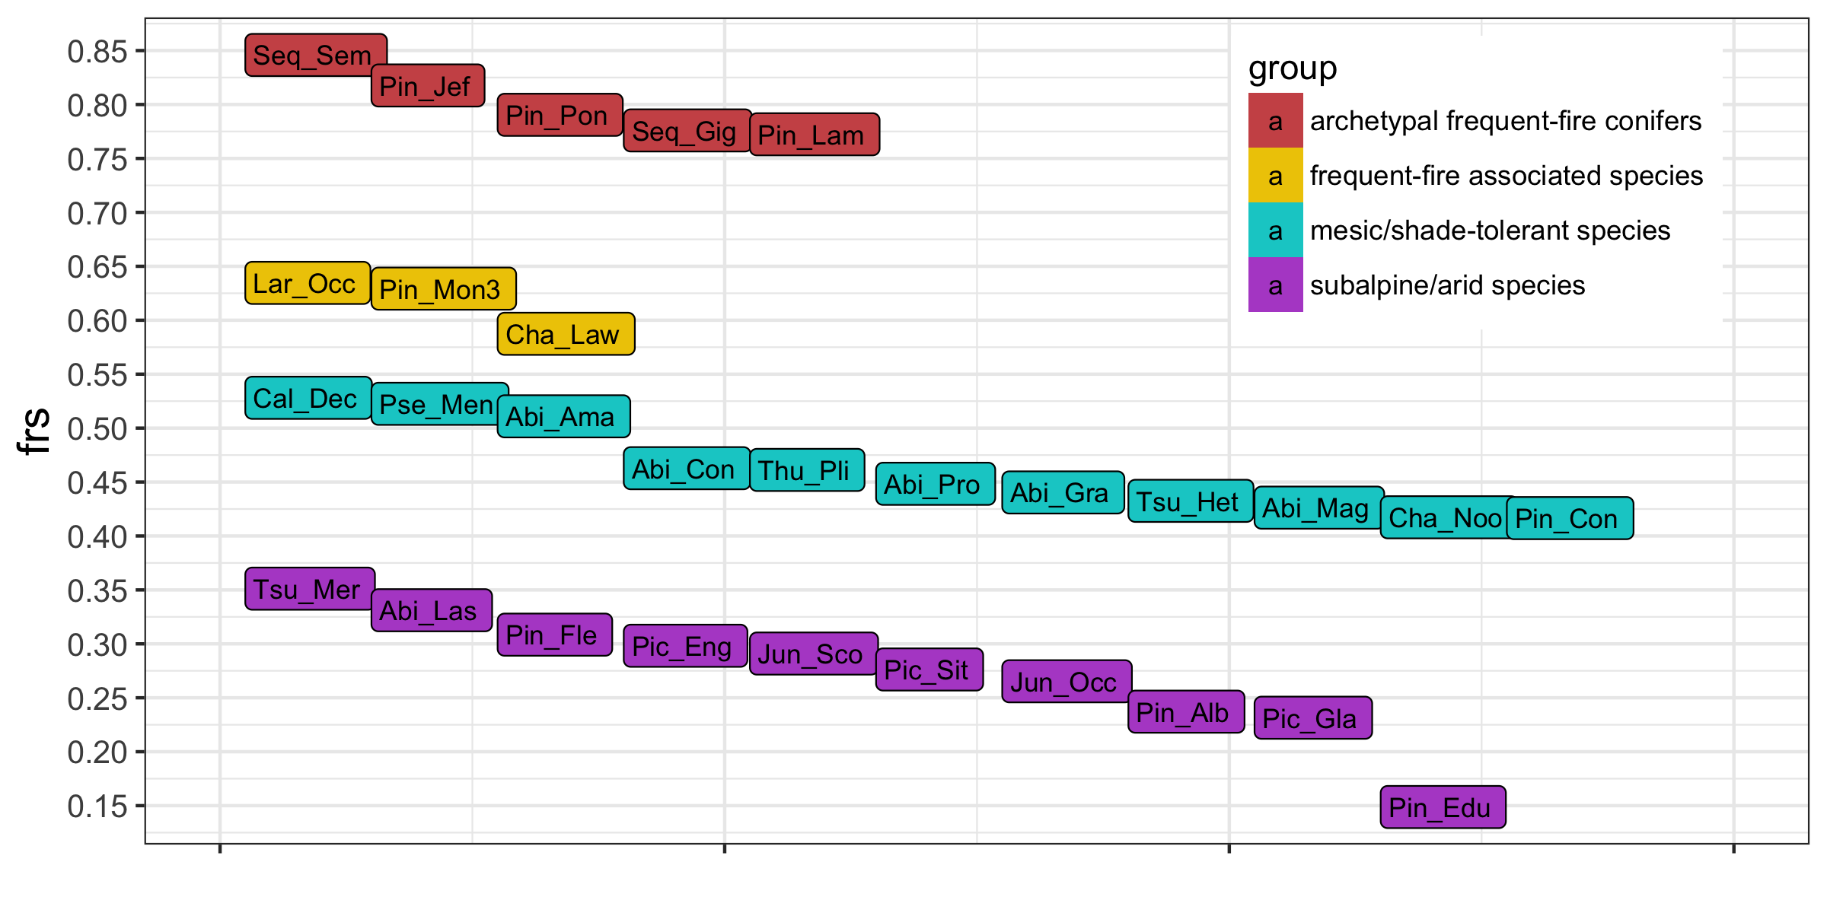

**Figure 2**: Ecological grouping of 29 conifer species by fire resistance scores (FRS). Species names are listed in Table 1

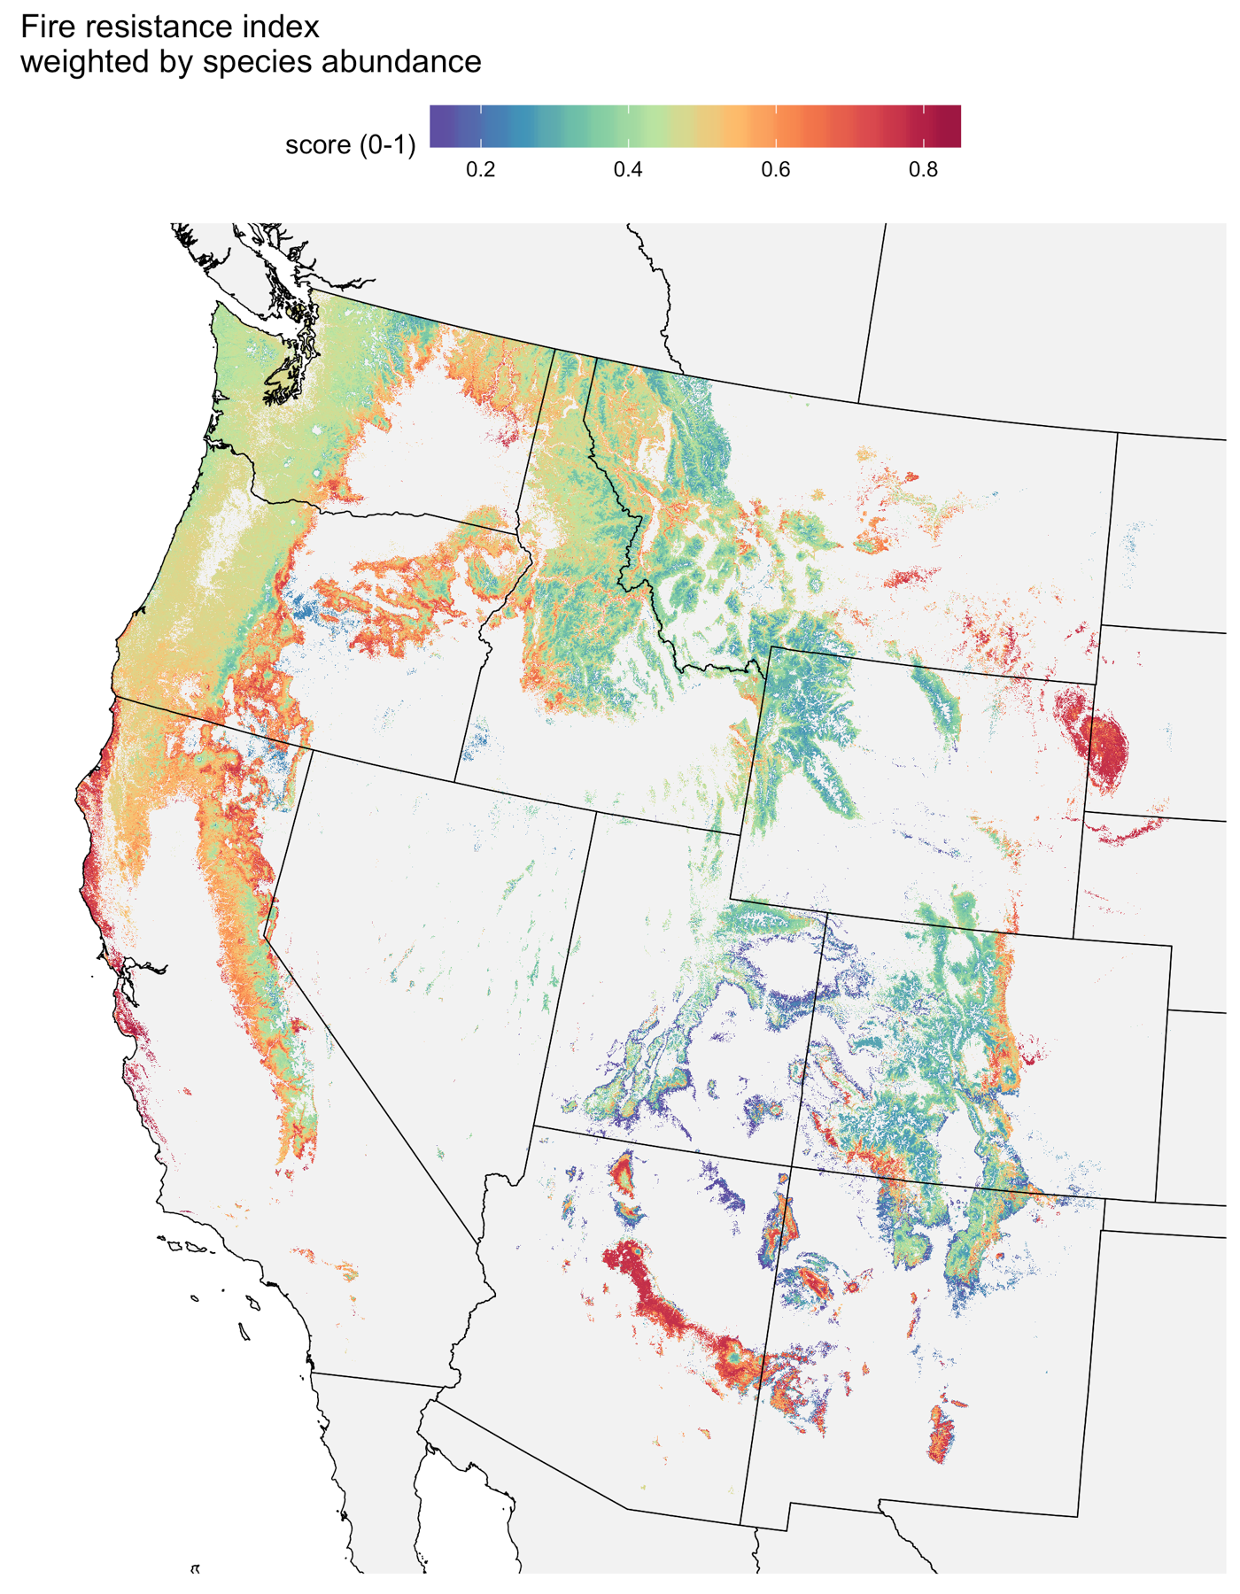

**Figure 3**: Fire resistance scores mapped across the landscape

**L****iterature Cited**

Brown, J. K., and J. K. Smith. 2000. Wildland fire in ecosystems: effects of fire on flora. Ogden, UT: U.S. Department of Agriculture, Forest Service, Rocky Mountain Research Station.

FEIS. 2013. Fire Effects Information System. Plant species descriptions., USDA Forest Service, Rocky Mountain Research Station, Fire Sciences Laboratory, Missoula MT.

Fonda, R. W. 2001. Burning Characteristics of Needles from Eight Pine Species. Forest Science **47**:390-396.

Fonda, R. W., L. A. Belanger, and L. L. Burley. 1998. Burning characteristics of western conifer needles. Northwest Science **72**:1-9.

Funk, J. L., J. E. Larson, G. M. Ames, B. J. Butterfield, J. Cavender-Bares, J. Firn, D. C. Laughlin, A. E. Sutton-Grier, L. Williams, and J. Wright. 2017. Revisiting the Holy Grail: using plant functional traits to understand ecological processes. Biological Reviews **92**:1156-1173.

Johnstone, J. F., C. D. Allen, J. F. Franklin, L. E. Frelich, B. J. Harvey, P. E. Higuera, M. C. Mack, R. K. Meentemeyer, M. R. Metz, G. L. W. Perry, T. Schoennagel, and M. G. Turner. 2016. Changing disturbance regimes, ecological memory, and forest resilience. Frontiers in Ecology and the Environment **14**:369-378.

Kattge, J., S. Díaz, S. Lavorel, I. C. Prentice, P. Leadley, G. Bönisch, E. Garnier, M. Westoby, P. B. Reich, I. J. Wright, J. H. C. Cornelissen, C. Violle, S. P. Harrison, P. M. Van Bodegom, M. Reichstein, B. J. Enquist, N. A. Soudzilovskaia, D. D. Ackerly, M. Anand, O. Atkin, M. Bahn, T. R. Baker, D. Baldocchi, R. Bekker, C. C. Blanco, B. Blonder, W. J. Bond, R. Bradstock, D. E. Bunker, F. Casanoves, J. Cavender-Bares, J. Q. Chambers, F. S. Chapin, J. Chave, D. Coomes, W. K. Cornwell, J. M. Craine, B. H. Dobrin, L. Duarte, W. Durka, J. Elser, G. Esser, M. Estiarte, W. F. Fagan, J. Fang, F. Fernández-Méndez, A. Fidelis, B. Finegan, O. Flores, H. Ford, D. Frank, G. T. Freschet, N. M. Fyllas, R. V. Gallagher, W. A. Green, A. G. Gutierrez, T. Hickler, S. I. Higgins, J. G. Hodgson, A. Jalili, S. Jansen, C. A. Joly, A. J. Kerkhoff, D. Kirkup, K. Kitajima, M. Kleyer, S. Klotz, J. M. H. Knops, K. Kramer, I. Kühn, H. Kurokawa, D. Laughlin, T. D. Lee, M. Leishman, F. Lens, T. Lenz, S. L. Lewis, J. Lloyd, J. Llusià, F. Louault, S. Ma, M. D. Mahecha, P. Manning, T. Massad, B. E. Medlyn, J. Messier, A. T. Moles, S. C. Müller, K. Nadrowski, S. Naeem, Ü. Niinemets, S. Nöllert, A. Nüske, R. Ogaya, J. Oleksyn, V. G. Onipchenko, Y. Onoda, J. Ordoñez, G. Overbeck, W. A. Ozinga, S. Patiño, S. Paula, J. G. Pausas, J. Peñuelas, O. L. Phillips, V. Pillar, H. Poorter, L. Poorter, P. Poschlod, A. Prinzing, R. Proulx, A. Rammig, S. Reinsch, B. Reu, L. Sack, B. Salgado-Negret, J. Sardans, S. Shiodera, B. Shipley, A. Siefert, E. Sosinski, J. F. Soussana, E. Swaine, N. Swenson, K. Thompson, P. Thornton, M. Waldram, E. Weiher, M. White, S. White, S. J. Wright, B. Yguel, S. Zaehle, A. E. Zanne, and C. Wirth. 2011. TRY – a global database of plant traits. Global Change Biology **17**:2905-2935.

Keeley, J. E., J. G. Pausas, P. W. Rundel, W. J. Bond, and R. A. Bradstock. 2011. Fire as an evolutionary pressure shaping plant traits. Trends in Plant Science **16**:406-411.

Larson, A. J., R. T. Belote, C. A. Cansler, S. A. Parks, and M. Dietz. 2013. Latent Resilience in Ponderosa Pine Forest: Effects of Resumed Frequent Fire. Ecological Applications.

Lutes, D., and R. Keane. 2017. First Order Fire Effects Model: FOFEM 6.4, User’s Guide. USDA Forest Service, Missoula, Mont, USA.

McGill, B. J., B. J. Enquist, E. Weiher, and M. Westoby. 2006. Rebuilding community ecology from functional traits. Trends in Ecology & Evolution **21**:178-185.

Messier, J., B. J. McGill, and M. J. Lechowicz. 2010. How do traits vary across ecological scales? A case for trait-based ecology. Ecology Letters **13**:838-848.

Millar, C. I., and N. L. Stephenson. 2015. Temperate forest health in an era of emerging megadisturbance. Science **349**:823-826.

Pausas, J. G. 2015. Bark thickness and fire regime. Functional Ecology **29**:315-327.

Pausas, J. G., J. E. Keeley, and D. W. Schwilk. 2017. Flammability as an ecological and evolutionary driver. Journal of Ecology **105**:289-297.

Riemann, R., B. T. Wilson, A. Lister, and S. Parks. 2010. An effective assessment protocol for continuous geospatial datasets of forest characteristics using USFS Forest Inventory and Analysis (FIA) data. Remote Sensing of Environment **114**:2337-2352.

Rollins, M. G. 2009. LANDFIRE: a nationally consistent vegetation, wildland fire, and fuel assessment. International Journal of Wildland Fire **18**:235-249.

Safford, H. D., and J. T. Stevens. 2017. Natural Range of Variation (NRV) for yellow pine and mixed conifer forests in the Sierra Nevada, southern Cascades, and Modoc and Inyo National Forests, California, USA. USDA Forest Service, Pacific Southwest Research Station. General Technical Report PSW-GTR-256, Albany, CA.

Schoennagel, T., and C. R. Nelson. 2011. Restoration relevance of recent National Fire Plan treatments in forests of the western United States. Frontiers in Ecology and the Environment **9**:271-277.

Schwilk, D. W., and D. D. Ackerly. 2001. Flammability and serotiny as strategies: correlated evolution in pines. Oikos **94**:326-336.

Schwilk, D. W., and A. C. Caprio. 2011. Scaling from leaf traits to fire behaviour: community composition predicts fire severity in a temperate forest. Journal of Ecology **99**:970-980.

Steel, Z. L., H. D. Safford, and J. H. Viers. 2015. The fire frequency-severity relationship and the legacy of fire suppression in California forests. Ecosphere **6**:art8.

Stevens, J. T., B. M. Collins, J. D. Miller, M. P. North, and S. L. Stephens. 2017. Changing spatial patterns of stand-replacing fire in California conifer forests. Forest Ecology and Management **406**:28-36.

USDA Forest Service FIA Program. 2014. Forest Inventory and Analysis National Core Field Guide. [http://www.fia.fs.fed.us/library/field-guides-methods-proc/docs/2014/Core FIA field guide_6-1.pdf](http://www.fia.fs.fed.us/library/field-guides-methods-proc/docs/2014/Core%20FIA%20field%20guide_6-1.pdf)

Varner, J. M., J. Kane, J. Kreye, and E. Engber. 2015. The Flammability of Forest and Woodland Litter: a Synthesis. Current Forestry Reports:1-9.

Wilson, B. T., A. J. Lister, R. I. Riemann, and D. M. Griffith. 2013. Live tree species basal area of the contiguous United States (2000-2009).*in* R. M. R. S. USDA Forest Service, editor., Newtown Square, PA.

Yocom-Kent, L. L., P. Z. Fulé, W. A. Bunn, and E. G. Gdula. 2015. Historical high-severity fire patches in mixed-conifer forests. Canadian Journal of Forest Research:1587-1596.

**Fig. S1**: Correlations between traits. Significance of correlations based on Pearson's product moment correlation coefficient, for P<0.001 (***) and P<0.05 (*).



**Fig. S2**: **Fire regime groups from LANDFIRE.** Groups 2 and 4 were masked to NA values (white).

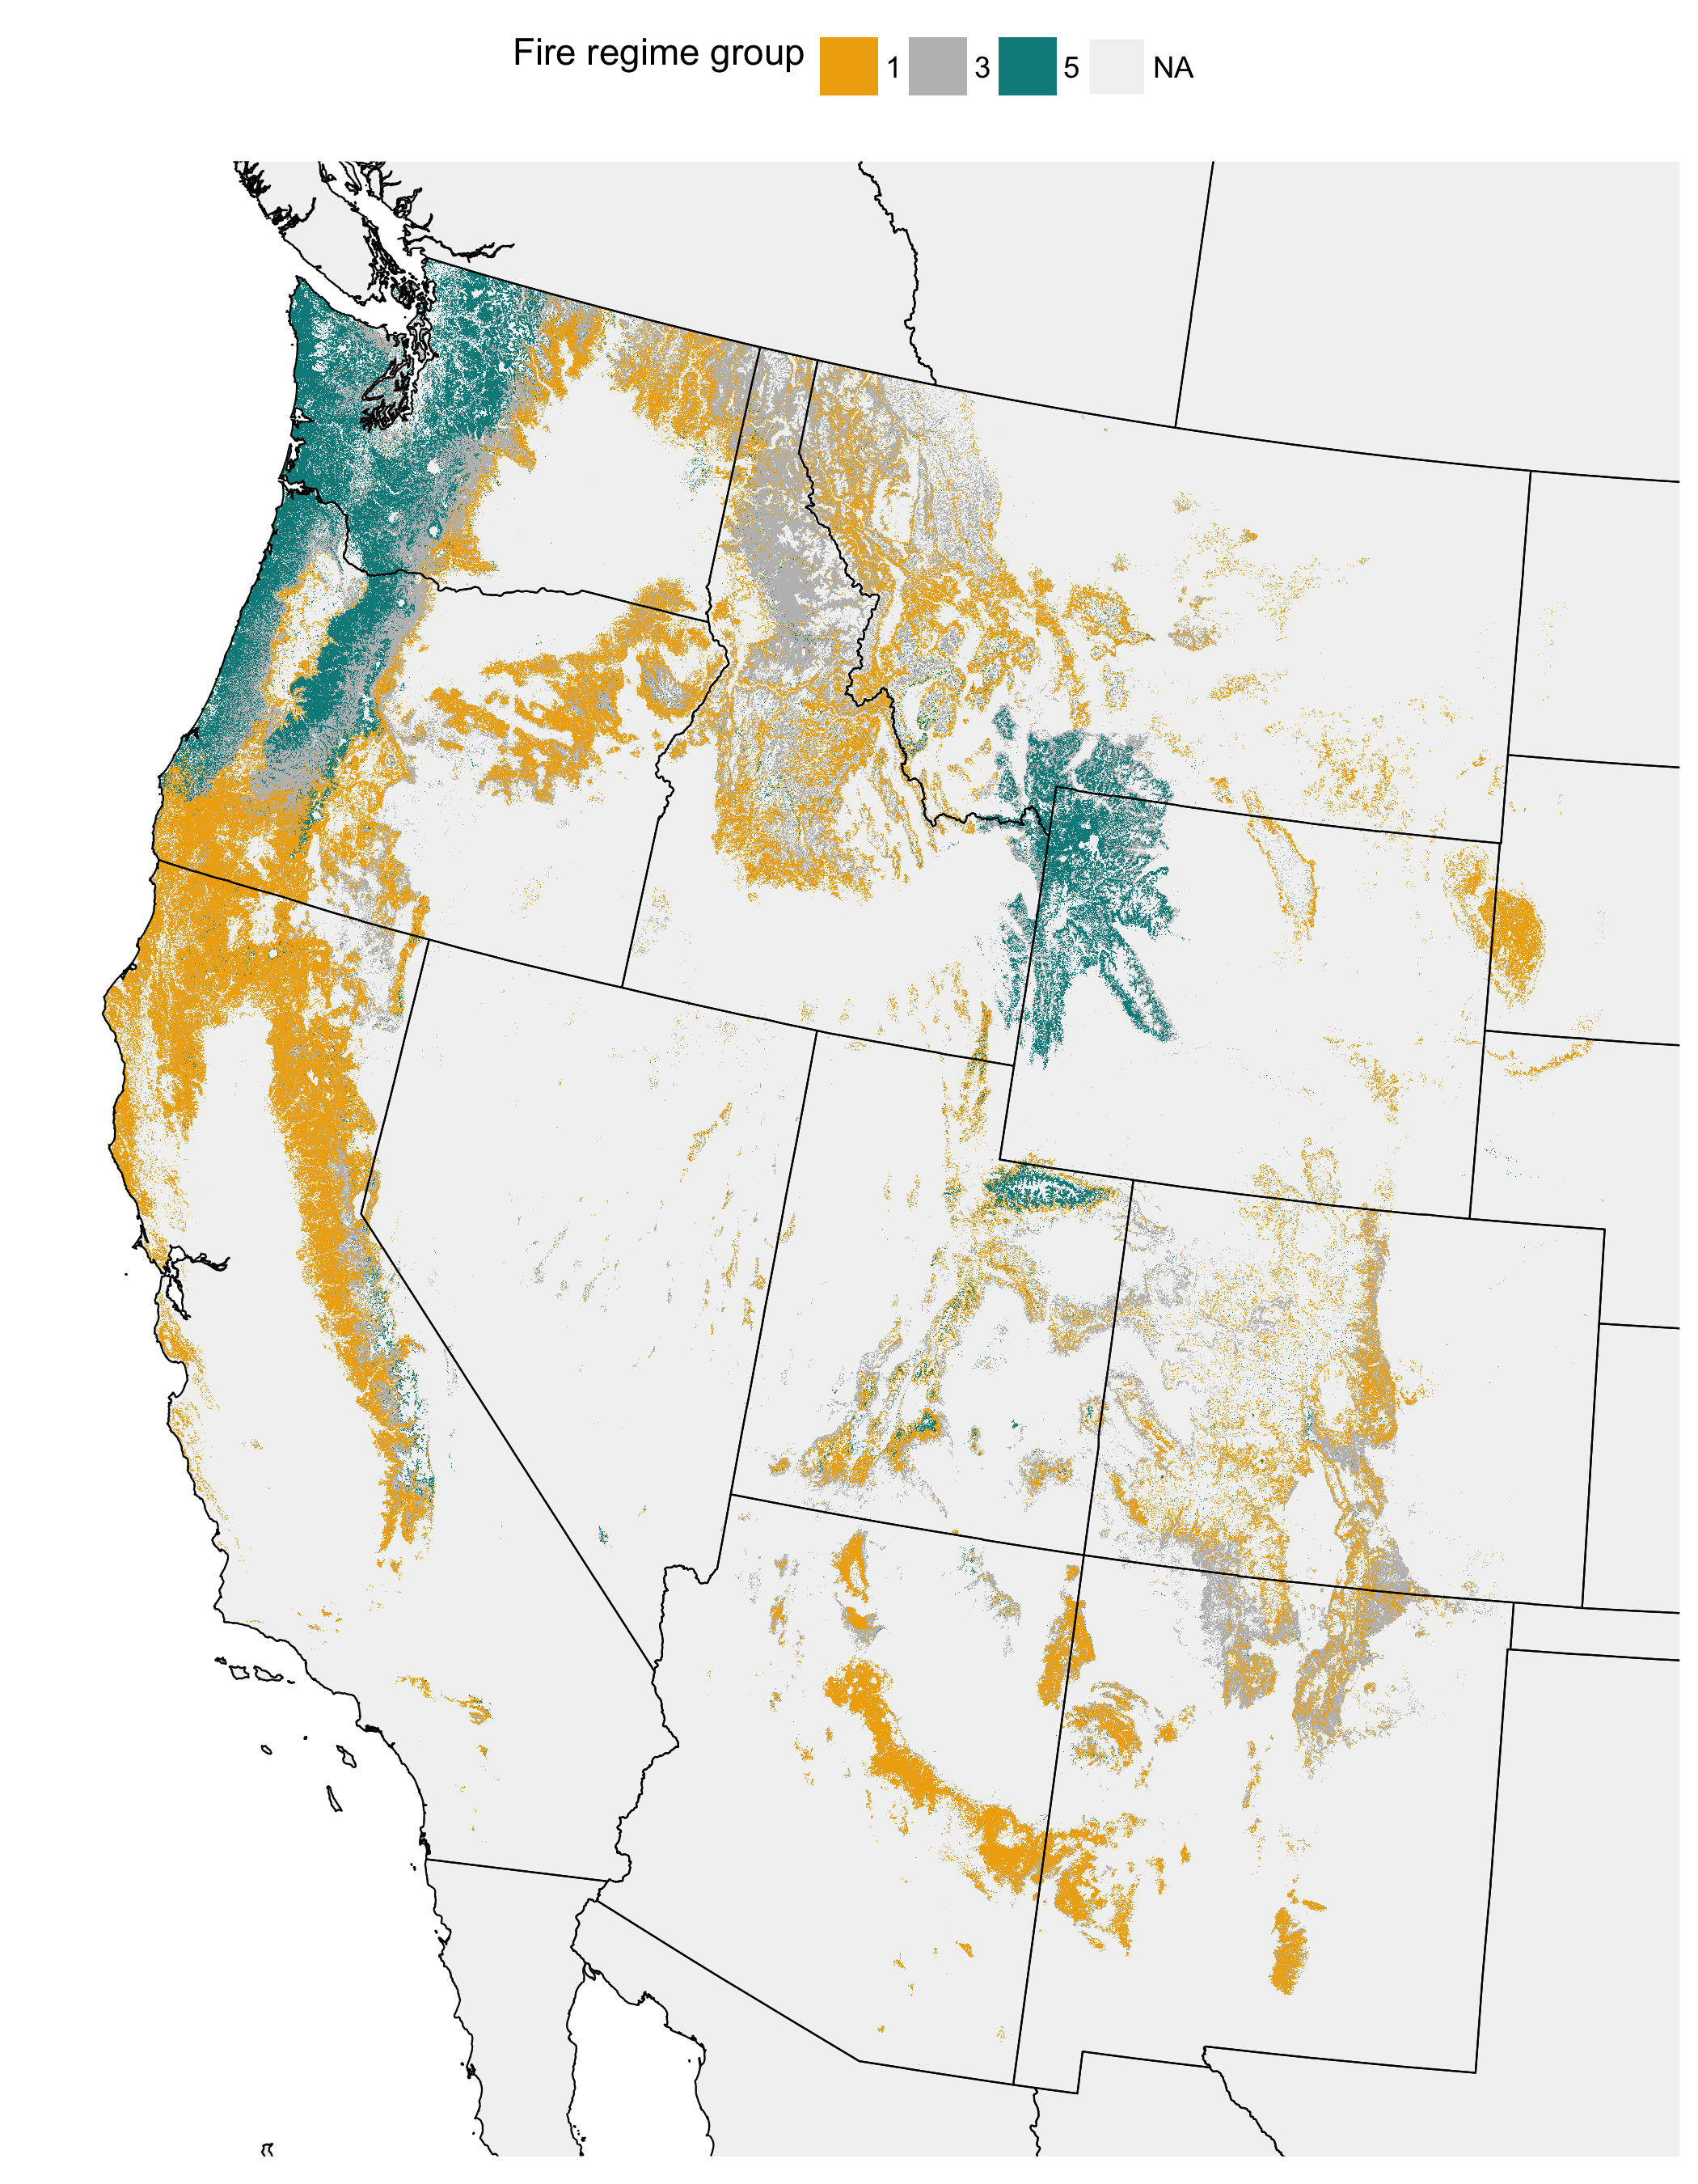

**Fig. S3: Fire return interval from LANDFIRE**

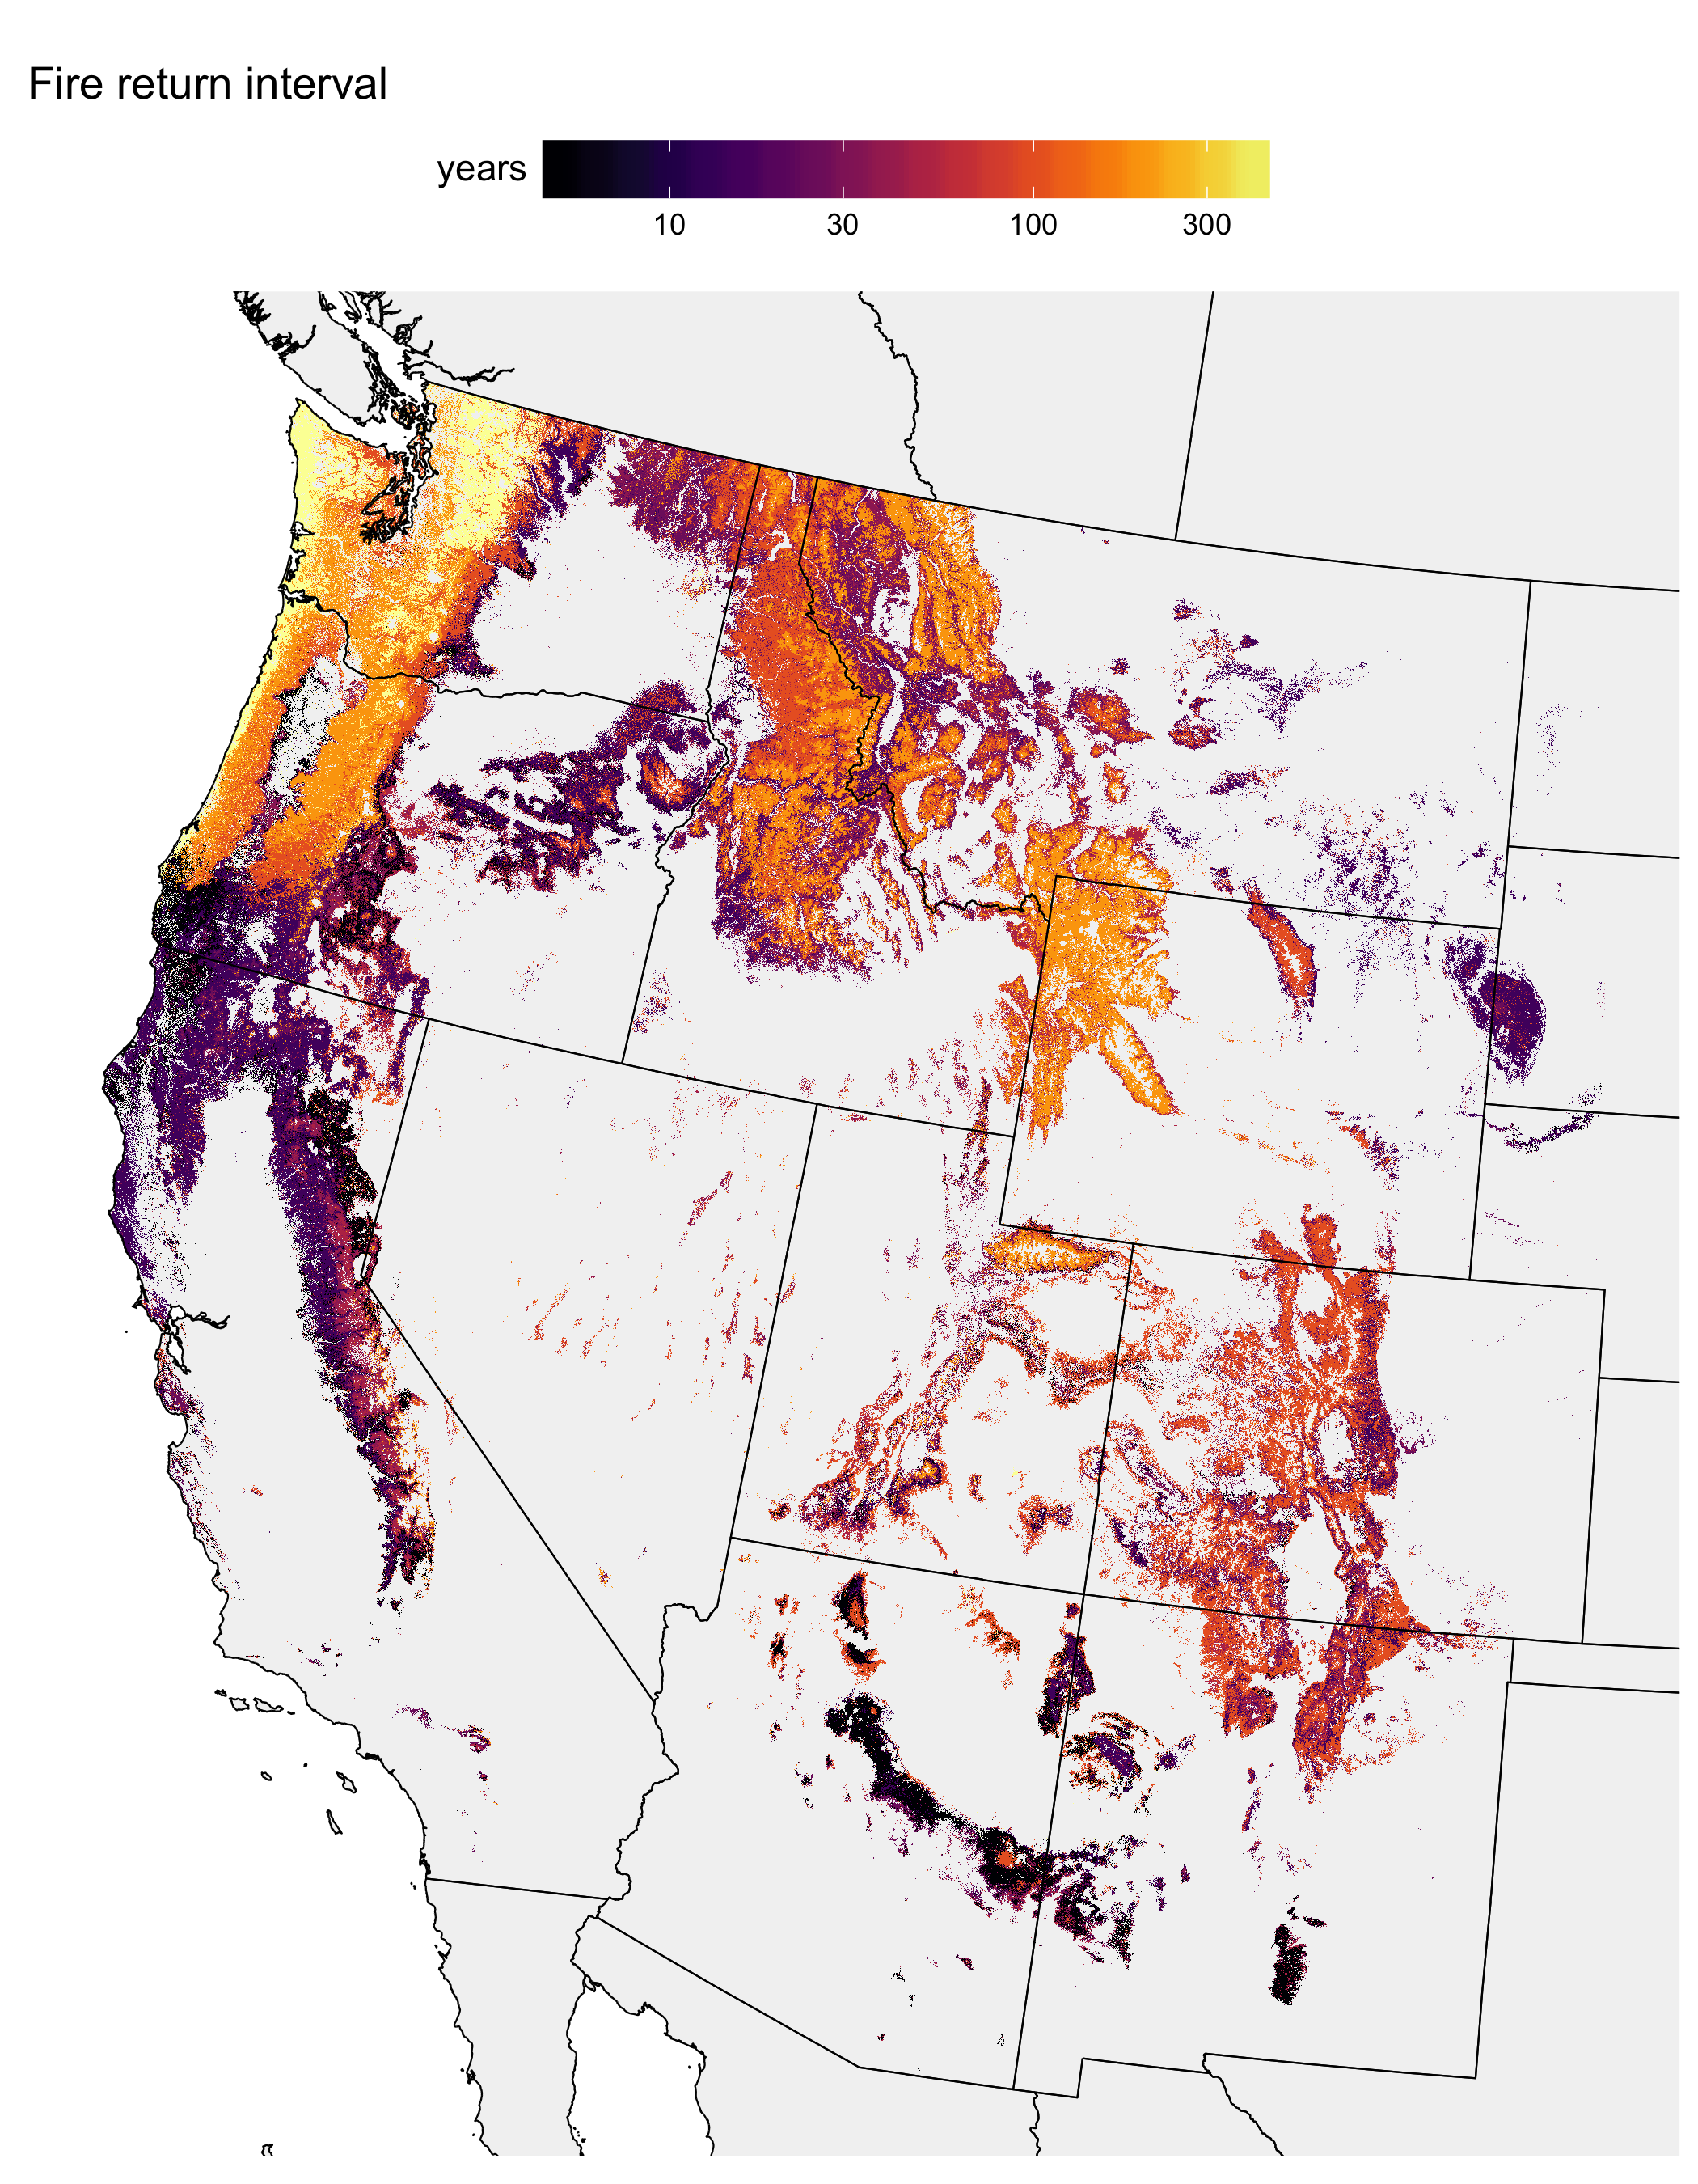

**Figure S4**

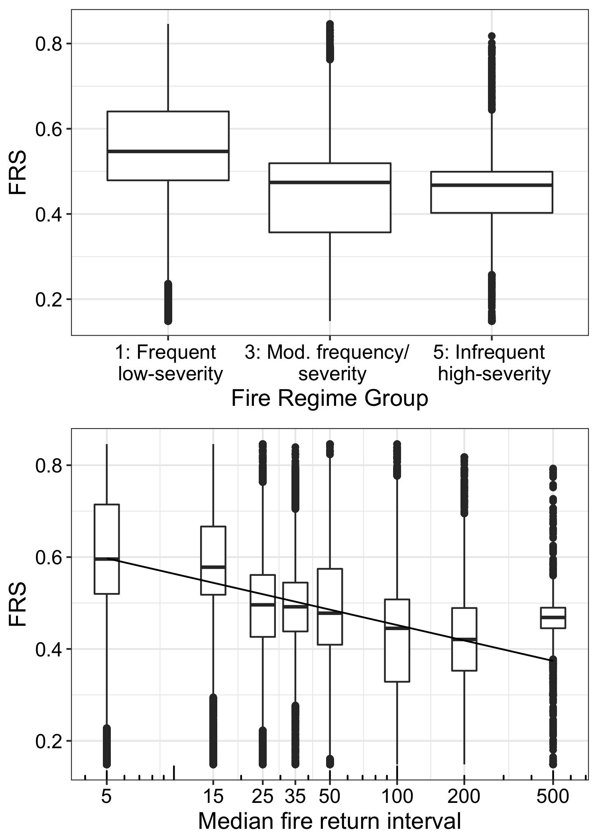

**Figure S5**: Potential imbalances between contemporary fire resistance traits and historical fire regimes. “Resistant” areas are defined as the 20% of forested areas with the highest fire resistance scores in areas defined as either intermediate (41-150 year) or infrequent (151-300 year) historical fire return intervals. “Vulnerable” areas are defined as the 20% of forested areas with the lowest fire resistance scores in areas defined as either intermediate or frequent (<20 year) historical fire return intervals.

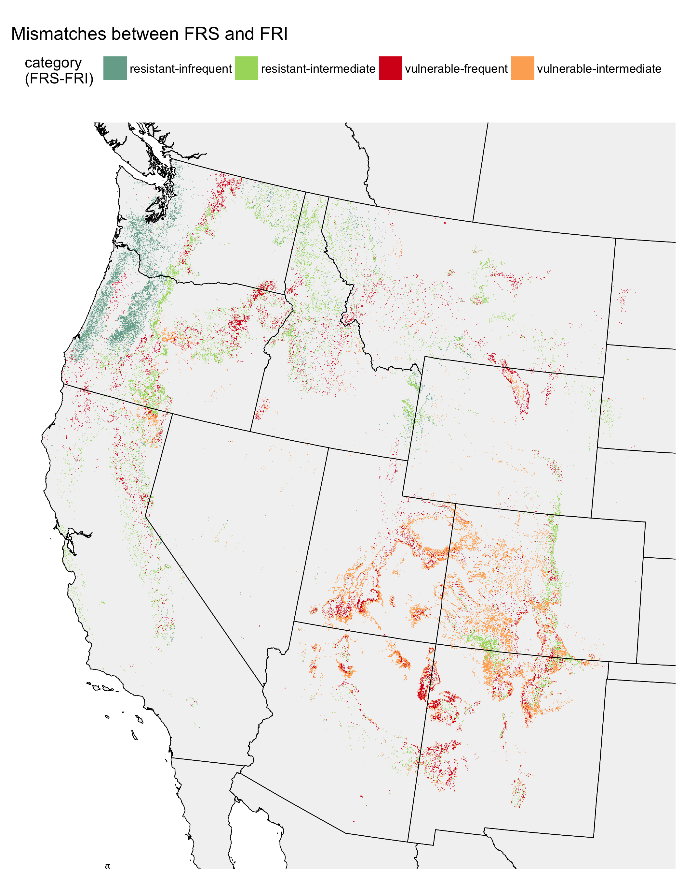

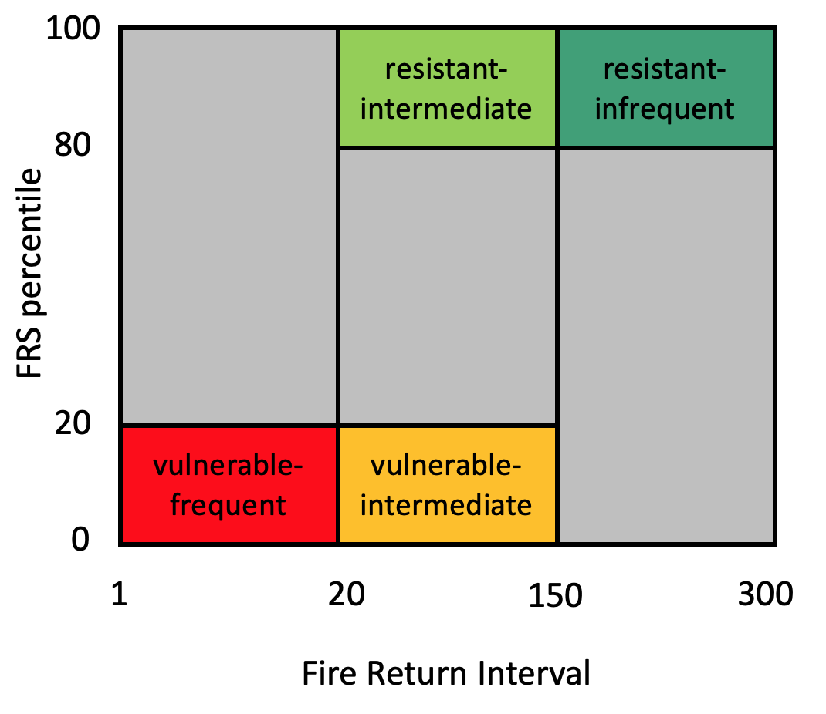

**References**

de Magalhaes, R. M. Q., and D. W. Schwilk. 2012. Leaf traits and litter flammability: evidence for non-additive mixture effects in a temperate forest. Journal of Ecology **100**:1153-1163.

Fonda, R. W. 2001. Burning Characteristics of Needles from Eight Pine Species. Forest Science **47**:390-396.

Fonda, R. W., L. A. Belanger, and L. L. Burley. 1998. Burning characteristics of western conifer needles. Northwest Science **72**:1-9.

Keeley, J. E., and P. H. Zedler. 1998. Evolution of life histories in *Pinus*. . Pages 219-250 Ecology and biogeography of *Pinus*. Cambridge University Press, Cambridge, U.K.

Pausas, J. G. 2015. Bark thickness and fire regime. Functional Ecology **29**:315-327.

Pausas, J. G., J. E. Keeley, and D. W. Schwilk. 2017. Flammability as an ecological and evolutionary driver. Journal of Ecology **105**:289-297.

Schwilk, D. W., and D. D. Ackerly. 2001. Flammability and serotiny as strategies: correlated evolution in pines. Oikos **94**:326-336.

Schwilk, D. W., and A. C. Caprio. 2011. Scaling from leaf traits to fire behaviour: community composition predicts fire severity in a temperate forest. Journal of Ecology **99**:970-980.

Varner, J. M., J. Kane, J. Kreye, and E. Engber. 2015. The Flammability of Forest and Woodland Litter: a Synthesis. Current Forestry Reports:1-9.